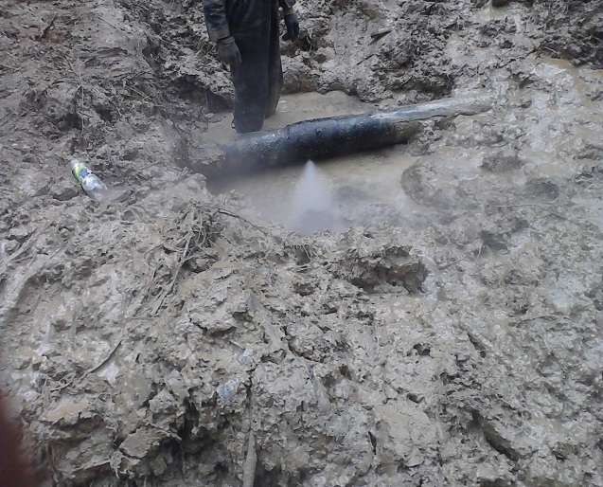 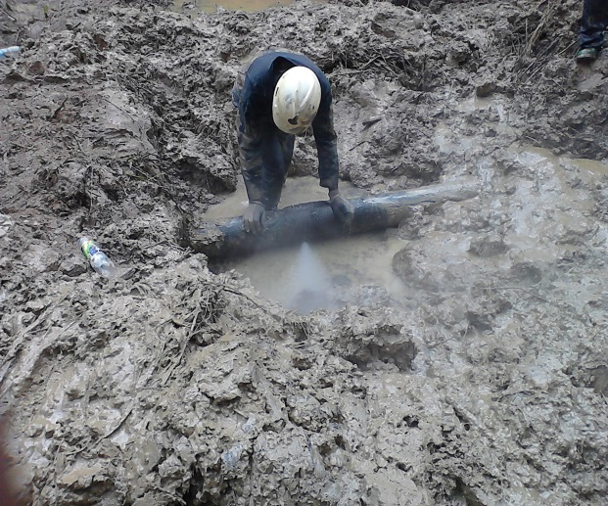 Fig. 1a Failed Welded Point Fig.1b @ 5 - 6 O’clock Position
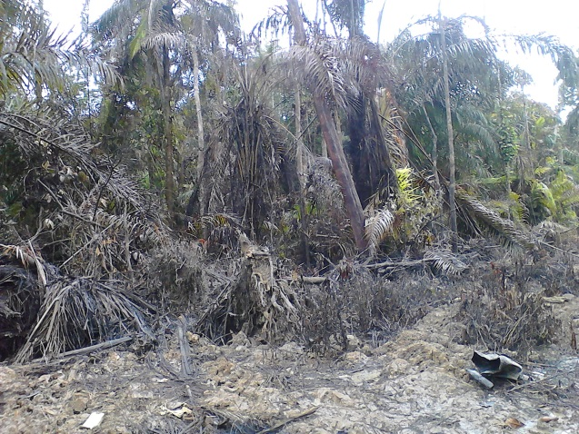 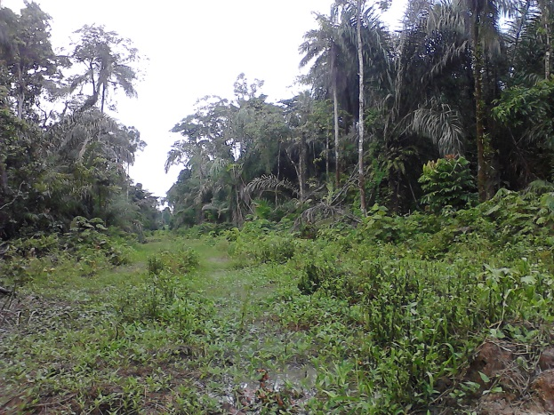 Fig. 2a Environment affected by Gas Spill Fig. 2b ROW & Vegetation
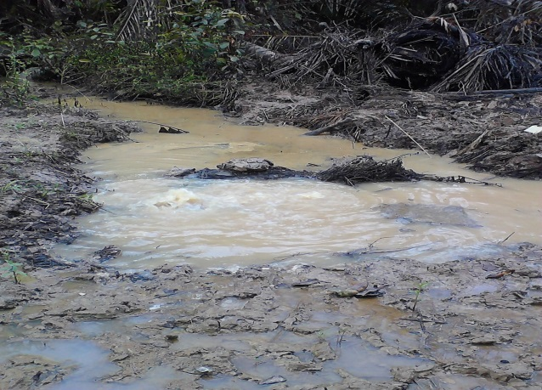 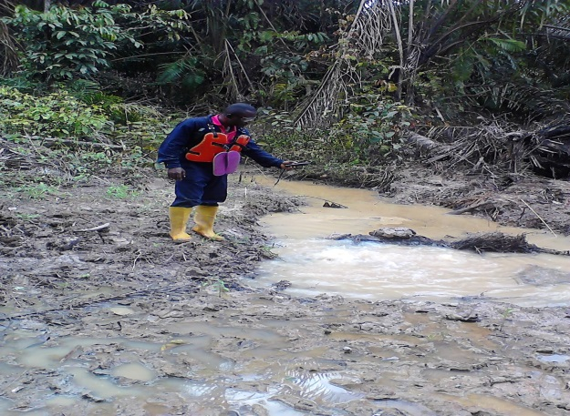 Fig. 3a Stream Water impacted by Gas Fig. 3b Bubbles of Gas in the Drinking Water
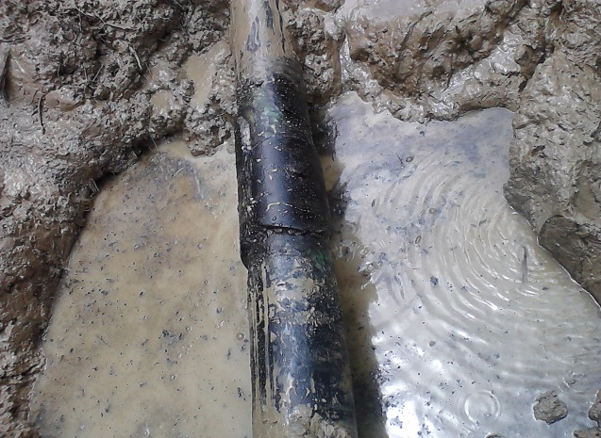 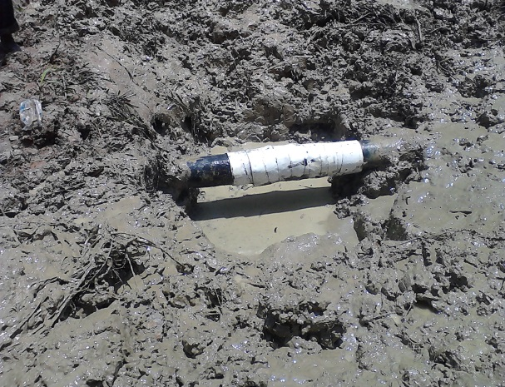Fig. 4a Flow Line Buried 1&1/2ft down Fig. 4b Failed Welded Point Wrapped

